Abasyn University Islamabad Campus

Name: M Farhan Tasawar
Reg No # 8684
Assignment # 04
Submitted to: Dr Saddaf Tanveer

Profile of Gum road:

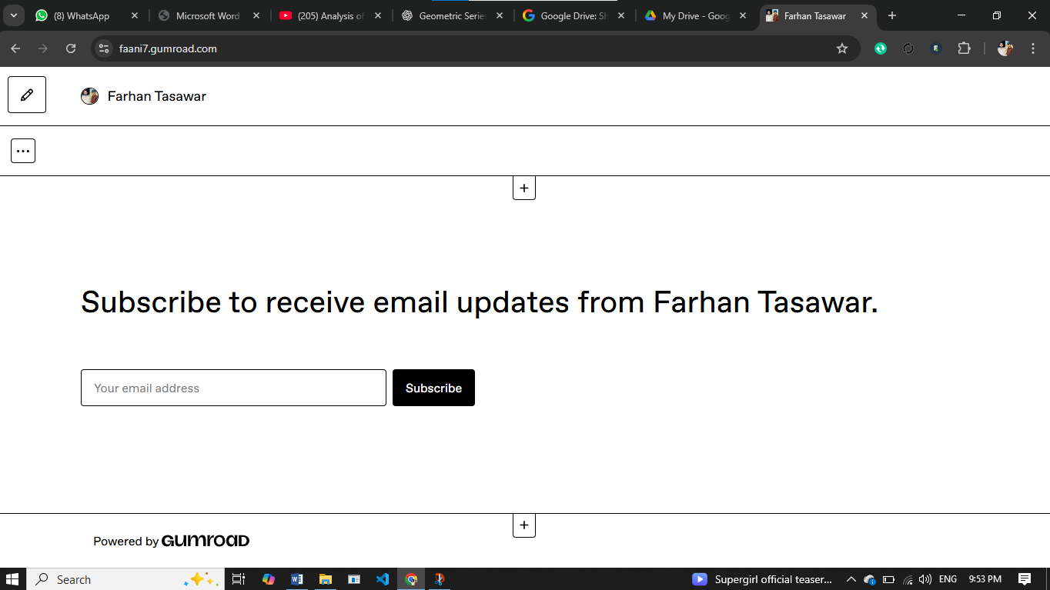

Products on Gum Rad:

